SIMATS ENGINEERING (SAVEETHA SCHOOL OF ENGINEERING)
Department of Computer Science and Engineering

CO1 ASSESSMENT TOOL 1 – Case Study Analysis

Course Code: | CSA10 / CSA1005 | Course Title: | Software Engineering
CO Assessed: | CO1 | Assessment: | Assessment Tool 1 – Case Study Analysis
Weightage: | 20% | Total Marks: | 25
CO1 Statement: | Apply advanced methodologies and agile project management techniques to manage software projects effectively
Student Name: | R. Yoga Nandhini | Reg. No.: | 192524101
Date: | 10-10-2026 | Duration: | 60 minutes
Code of Conduct
I R.Yoga Nandhini (192524101) (Name / Reg No) certify that this submission is my original work and that I have adhered to the guidelines specified for this assessment. I understand that any violation of academic integrity rules will result in disciplinary action.
Signature of the Student: R. Yoga Nandhini
Annexure A – Case Study Analysis

DIGITAL ALUMNI ENGAGEMENT AND NETWORKING PLATFORM
1. Understanding the Problem Statement
Universities have many former students (alumni) working in different industries and professions. They can support current students by sharing career guidance, mentoring, job openings, professional experience, and institutional updates. At present, this information may be spread across social media, email groups, spreadsheets, and separate event registrations. As a result, it can be difficult to keep records updated and maintain regular communication.
The proposed Digital Alumni Engagement and Networking Platform is a centralized web-based system. It allows alumni to create professional profiles, connect with students, volunteer as mentors, publish job opportunities, register for alumni events, and contribute to university activities. Students can search for suitable alumni, request mentorship, and explore career opportunities. Administrators can manage accounts, verify information, publish announcements, and measure engagement.

Objectives
- Maintain accurate alumni profiles and professional details.
- Enable secure networking between alumni and current students.
- Organize mentorship requests, mentor availability, and progress.
- Publish job openings, internships, and referral opportunities.
- Manage alumni events, registrations, and announcements.
- Record donations, volunteering, guest lectures, and other contributions.
- Generate reports and analytics about alumni participation.

Scope
The system covers account registration, profile management, search, mentorship, jobs, events, notifications, contributions, and analytics. It can be accessed through a computer or mobile browser. The first version may focus on one university and later expand to multiple departments or campuses. It does not guarantee a job or mentorship outcome; it provides the tools needed to connect people and manage engagement efficiently.

2. Key Stakeholders and Challenges
The main stakeholders and their responsibilities are:
- Alumni: Create and update professional profiles, offer mentorship, share job opportunities, attend events, and contribute to institutional initiatives.
- Current students: Search for alumni, request guidance, apply for opportunities, attend events, and communicate professionally.
- University administration / alumni office: Verify alumni records, manage events and announcements, coordinate programs, and review engagement reports.
- Faculty and placement cell: Recommend mentors, share student career needs, coordinate guest lectures, and validate relevant job information.
- System administrator / IT team: Manage access permissions, backups, security, technical support, and system availability.
- Employers and industry partners: Share approved vacancies, internship details, and suitable referral opportunities.

Major challenges
- Outdated contact details and incomplete alumni profiles.
- Low participation when alumni receive too many unrelated messages.
- Privacy concerns about phone numbers, employment details, and personal information.
- Fake accounts, misleading job posts, or inappropriate messages.
- Difficulty matching students with mentors based on skills, goals, and availability.
- Different departments using separate records and inconsistent data formats.
- Limited budget, staff time, and technical support for long-term maintenance.

3. Analysis of the Current Approach
In a typical existing process, alumni details are stored in spreadsheets or old institutional databases. Communication takes place through email, messaging groups, social networks, or department contacts. Mentorship may be arranged informally by faculty, while job openings and event invitations are shared in separate channels. Participation is often counted manually after an event.
Strengths
- Familiar tools are easy to start using and may have little initial cost.
- Social networks can reach a large number of alumni quickly.
- Email and messaging groups support fast announcements.
Limitations and gaps
- Information is fragmented and may be duplicated or inconsistent.
- There may be no single verified directory of alumni and their skills.
- Mentorship requests can be lost, delayed, or difficult to track.
- Job posts and events are not always connected to a student’s interests.
- Manual reporting takes time and may not show meaningful engagement trends.
- Access control, consent, and data retention may not be managed consistently.
The key gap is the absence of one trusted platform that links alumni profiles with mentoring, careers, events, contributions, communication, and reporting.

4. Proposed Solution Using Software Engineering Principles
The proposed solution is a secure, responsive web application with role-based access. Users sign in and see features appropriate to their role. Alumni can maintain profiles and offer support; students can search and request connections; administrators can verify records and manage activities. A shared database stores the information so that updates are reflected across modules.

Major functional modules
1. User Registration and Login: Registration, authentication, password reset, role assignment, and account verification.
2. Alumni Profile Management: Name, graduation year, department, skills, employer, job role, experience, and preferred contact settings.
3. Networking and Search: Search and filter alumni by industry, skills, graduation year, location, or professional role; send connection requests.
4. Mentorship Management: Mentors set interests and availability; students submit requests; both sides can track status and meeting schedules.
5. Jobs and Referrals: Authorized users publish jobs or internships with eligibility, deadline, location, and application details.
6. Events and Announcements: Publish reunions, webinars, guest lectures, and university events; manage registration and attendance.
7. Contributions Management: Record approved donations, volunteering, guest talks, scholarships, equipment, and other support.
8. Notifications and Analytics: Send relevant reminders and show totals for active alumni, mentorships, event attendance, job posts, and contributions.
Functional requirements
- The system shall allow users to register, sign in, and update permitted profile fields.
- The system shall allow students to search alumni and submit mentorship requests.
- The system shall allow verified users to post jobs and internship opportunities.
- The system shall allow users to view events and register or cancel registration.
- The administrator shall verify profiles, manage content, and suspend inappropriate accounts.
- The system shall generate summary reports on engagement and participation.
Non-functional requirements
- Security: use secure authentication, role-based permissions, encryption in transit, and protected backups.
- Privacy: collect only necessary data and let users control visibility and communication preferences.
- Usability: provide clear menus, readable forms, search filters, and mobile-friendly pages.
- Reliability: validate inputs, handle errors safely, and maintain regular backups.
- Performance: common searches and pages should load promptly under normal university usage.
- Scalability: allow more alumni, departments, and campuses to be added without redesigning the whole system.
- Maintainability: separate modules and document code so changes can be tested and deployed safely.
Software engineering principles
Modularity is achieved by separating profiles, mentorship, jobs, events, contributions, and reports. Scalability is supported through a structured database, reusable services, and the ability to add capacity when user numbers grow. Maintainability is improved by consistent coding standards, documentation, version control, and automated tests. Reliability is supported by input validation, error handling, backups, and monitoring. Usability is improved through simple navigation, accessible forms, and responsive design. Security is built in through least-privilege access, secure password handling, consent-based profile visibility, moderation, and audit logs for important administrative actions.
.
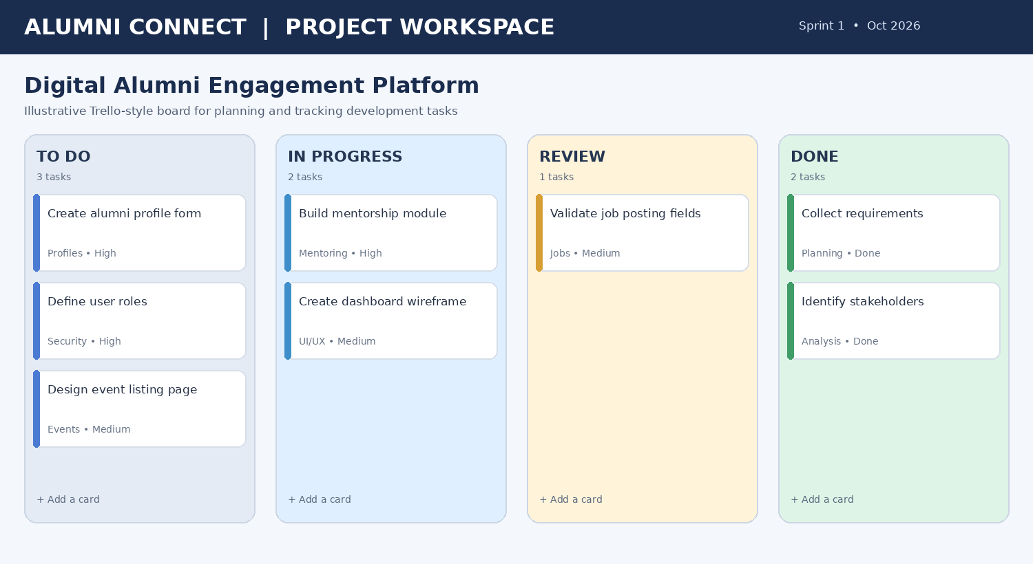
Figure 1. Example task board for planning the Alumni Connect platform.
5. Justification of the SDLC Methodology
Agile development using Scrum is suitable for this platform. The system contains several independent modules, and stakeholder needs may change after alumni, students, and administrators test early versions. Scrum divides work into short sprints, usually one to two weeks, and produces a working increment at the end of each sprint.
Suggested sprint plan:
- Sprint 1 – Requirements, stakeholder interviews, user stories, and interface wireframes.
- Sprint 2 – Registration, login, role permissions, and alumni profile management.
- Sprint 3 – Alumni search, connection requests, and mentorship workflows.
- Sprint 4 – Job postings, events, registrations, and notifications.
- Sprint 5 – Contributions, analytics dashboard, security checks, and usability testing.
- Sprint 6 – User acceptance testing, bug fixes, deployment, documentation, and training.
At sprint planning, the team selects tasks from the product backlog. During the sprint, short daily meetings help identify blockers. At the sprint review, stakeholders provide feedback on completed features. The retrospective helps the team improve its process. A product owner prioritizes features, a Scrum Master helps remove process obstacles, and developers design, build, and test the system.
Agile is appropriate because the team can deliver useful features early, collect feedback, and adjust priorities. For example, a basic alumni directory can be released before advanced analytics. Automated tests, code reviews, version control, and a staging environment should be used throughout development. After release, the team can plan maintenance work through the same backlog.

6. Expected Outcomes, Risks, Limitations, and Future Enhancements
Expected benefits
- A centralized and more accurate alumni directory.
- More structured mentoring relationships between students and alumni.
- Easier access to internships, job postings, and referrals.
- Improved communication about reunions, webinars, and university activities.
- Clear records of volunteering, donations, guest lectures, and other contributions.
- Reports that help the institution understand participation and improve engagement.
Risks and implementation challenges
- Alumni may not register or keep profiles updated; periodic reminders and simple profile updates can help.
- Incorrect or fraudulent content may be posted; use verification, reporting, and moderation processes.
- Personal data may be exposed if permissions are misconfigured; conduct security reviews and restrict access.
- Development may be delayed by limited time or budget; prioritize a minimum viable product and deliver in stages.
- Users may find the system difficult at first; provide a short guide, onboarding, and support contact.
- Analytics may be misleading if records are incomplete; define metrics clearly and show the reporting period.
Limitations
The platform cannot force alumni to participate, guarantee employment, or ensure that every mentorship is successful. Data accuracy depends on users and institutional verification. Notifications may be ignored, and the system requires continuing hosting, maintenance, moderation, and privacy compliance. Integration with existing university databases may require additional time and permission.
Future enhancements
- A mobile application with push notifications.
- AI-assisted mentor recommendations based on skills and career interests, with human oversight.
- Integration with the university student information system and approved job portals.
- Virtual mentoring rooms, calendar integration, and meeting reminders.
- Multilingual support and accessibility improvements.
- Advanced dashboards showing engagement trends by department and graduation year while protecting privacy.

Conclusion
The Digital Alumni Engagement and Networking Platform offers a practical way to bring alumni information, mentorship, jobs, events, and institutional contributions into one system. A modular design and Agile Scrum development approach make the project easier to build, test, and improve in stages. With appropriate security, privacy controls, verification, and user support, the platform can strengthen alumni relationships and create more opportunities for current students and the university.

Rubrics for Calculation
Criteria | Excellent (5 Marks) | Good (3 Marks) | Satisfactory (2 Marks) | Needs Improvement (1 Mark)
Problem | Clearly explains | Explains the | Basic | Poor
Understanding | the problem, | problem with | understanding | understanding;
(30%) | objectives, and | minor omissions. | with limited | objectives and
 | scope with |  | explanation. | scope are
 | complete |  |  | unclear or
 | understanding. |  |  | missing.
Stakeholder & | Identifies all | Identifies most | Identifies only a | Stakeholders
Challenge | stakeholders, their | stakeholders and | few | and system
Analysis | roles, and | challenges with | stakeholders or | analysis are
(25%) | challenges with | adequate | challenges. | incomplete or
 | clear analysis. | analysis. |  | inaccurate.
Current | Thoroughly | Good analysis | Limited analysis | Proposed
System | analyzes the | with most | with partial | solution is
Analysis | existing system, | strengths and | identification of | unclear or
(20%) | strengths, | weaknesses | issues. | inappropriate;
 | weaknesses, and | identified. |  | requirements are
 | identifies all gaps. |  |  | largely missing.
Proposed | Proposes an | Suitable solution | Basic solution
Software | innovative, | with good | with limited
Solution & | feasible solution | application of | application of
Software | applying | software | software
Engineering | appropriate | engineering | engineering | Methodology is
Principles | software | principles. | principles. | inappropriate,
(15%) | engineering |  |  | poorly justified,
 | principles |  |  | or not discussed.
 | (modularity,
 | scalability,
 | maintainability,
 | security, etc.).
Methodology/ Framework Justification | Selects the most suitable SDLC/model/fram | Suitable methodology selected with | Methodology selected but justification is | Outcomes, limitations, or future  enhancements

(10%) | ework and provides strong technical justification. | adequate justification. | weak. | are missing; report lacks organization and clarity.

Criteria | Mark
Problem Understanding (30%) | /5
Stakeholder & Challenge Analysis (25%) | /5
Current System Analysis (20%) | /5
Proposed Software Solution & Software Engineering Principles (15%) | /5
Methodology/ Framework Justification (10%) | /5
TOTAL | /25

